***Headteacher: Mr Simon Goodwin***

**Plymyard Avenue, Eastham, Wirral, CH62 8EH**

**Tel: 0151 327 3213**

[**www.southwirral.wirral.sch.uk**](http://www.southwirral.wirral.sch.uk)

**11-18 mixed comprehensive, circa 1100 on roll, Group 6**

**TEACHER OF ENGLISH**

**MPS/UPS**

**Full-time, permanent contract from 1st September 2023**

South Wirral High School is a co-educational foundation secondary school and sixth form located in Eastham, Merseyside, England. The school prides itself on its community ties, working closely with nearby primary schools to help with students' transition to high school. This commitment is shown in our motto "Raising Achievement in Partnership with Families and the Community". This declares a vision for our school where each student’s progress is remarkable. We focus on the whole educational experience, aiming for success in examinations and other aspects of school life. This includes sports, the arts and as contributors to our community. Extra-curricular activities are an integral part of school life, as we help students to build skills in the 5 'LORIC' principles - Leadership, Organisation, Resilience, Initiative and Character.

The person appointed will join an outstanding English team with an unswerving commitment to ensure that every student achieves their goals, whatever their circumstances. South Wirral High School is a school that has improved rapidly in recent years, recognised by Ofsted, receiving a judgment of “Good” as the outcome of an Ofsted Inspection in October 2022.

The person appointed will teach across age and ability range at all Key Stages, including the Sixth Form.

The English Faculty has introduced GCSE and A Level Film Studies so knowledge and/or experience of that subject would be an advantage.

The Assessment Process will be: Student voice panel (25%)

Lesson observation (25%)

Interview (50%)

Closing date: Thursday 16th March 2023

Interview date: Week beginning Monday 20th March 2023

We are sorry that it will not be possible to contact unsuccessful candidates. Anyone who has not heard of the progress of their application Friday 17th Marchmust assume it has been unsuccessful.

Please see the school’s website [www.southwirral.wirral.sch.uk](http://www.southwirral.wirral.sch.uk) for further details and an application form.

Completed application forms and letter of application to be addressed to Headteacher, either by post or email to [recruitment@southwirral.wirral.sch.uk](mailto:recruitment@southwirral.wirral.sch.uk)

**The post is subject to an Enhanced Level DBS check.**

**The school is committed to safeguarding and promoting the welfare of children and young people and expects all staff and volunteers to share this commitment**

**All applicants will be considered on the basis of suitability for the post regardless of sex, race or disability**

**Our Safeguarding Policy can be found on our school’s website:**

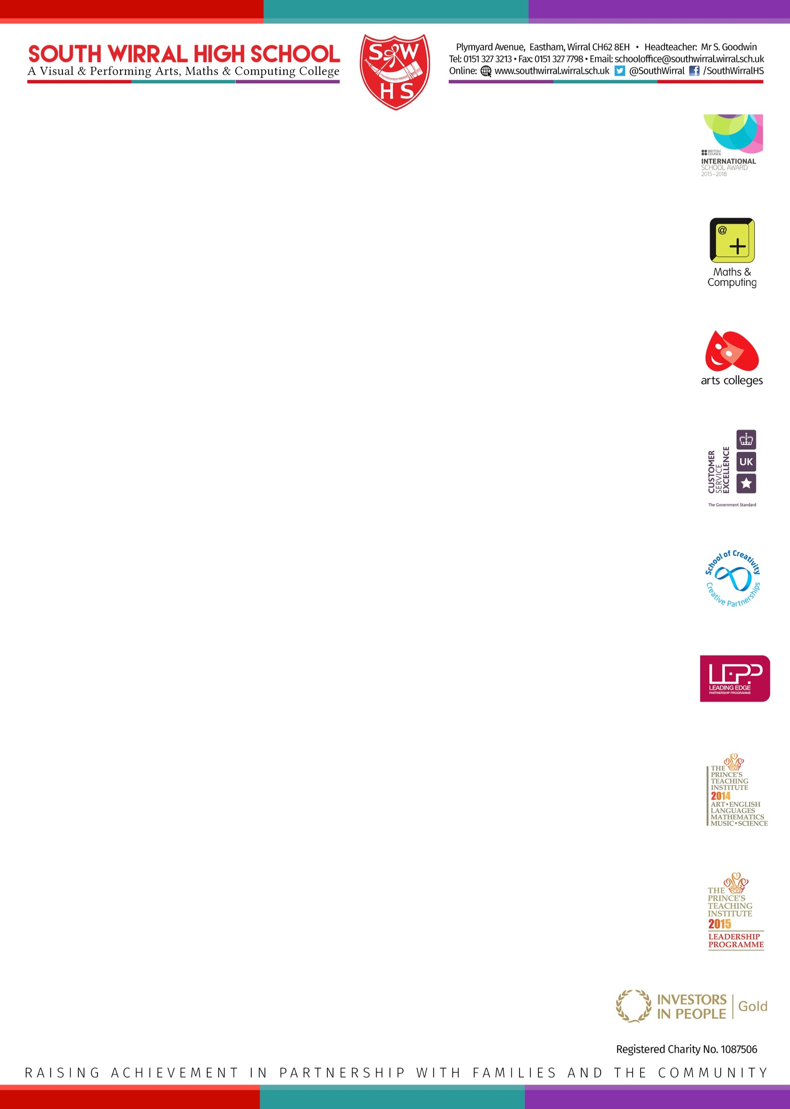[www.southwirral.wirral.sch.uk/wp-content/uploads/2017/10/Safeguarding-Child-Protection-Policy-2016-17.pdf](http://www.southwirral.wirral.sch.uk/wp-content/uploads/2017/10/Safeguarding-Child-Protection-Policy-2016-17.pdf)